FONTYS UNIVERSITY OF APPLIED SCIENCES

HBO-ICT: English Stream

Project Core Phase

**User Requirement Specification**

**Modular epidemiological hospital efficiency simulator**

Students:

Amin Masoumzadegan Jahromi

Danas Jusys

Dayana Naydenova

Edgaras Spiridonovas

Ella Seyedkabirian

Project leader: Mateusz Ulas

Tutor:

Andrius Kuprys

**UML Class Diagram** **4**

**Description of the UML Class Diagram** **4**

Hospital 4

Person 5

Patient 5

Nurse 5

Doctor 5

Qualification 5

Member 5

IlockdownPolicy 6

Policy 6

Community 6

HM_object 6

**Use Case Diagram** **8**

**Save and load - Sequence Diagrams** **9**

**Policy - Sequence Diagram** **11**

**Hospital - sequence diagram** **16**

**Unit tests - description** **17**

CalculateBlockCountTest 17

CalculateBlockCount2Test 17

GetNameTest 17

GetAgeTest 17

GetGenderTest 18

checkForMoreStaff_If_buget_more_then_0_ReturnsTrue 18

getBudget_Returns10000 18

getPopulation_Returns5000 19

getHerdSufficiency_60 19

getAreaDensity_500 19

getPopulation_10000 19

getCultureType_declared_value_Median 19

### 

### 

### 

### 

### 

### 

### 

### 

### 

### 

### 

### 

### 

### 

### UML Class Diagram

### Description of the UML Class Diagram

#### Hospital

Hospital has a constructor with population, budget, and initial policy as parameters, it also creates new lists for doctors, nurses, patients, and history of the simulation.

Method initiateHospitalList() takes number of districts and qualification as parameters, it calculates the number of potential doctors and nurses and returns true if hiring was successful, otherwise it returns false.

Methods hireNurse() and hireDoctor() check if there is enough budget, and if there are enough doctors/nurses for simulation to start, based on these if statements reduces salaries from budget and returns true/false.

socialEvent() returns socialEvent with parameters: member list, culture, density, and district.

newPolicy() updates instancePolicy to a new one.

updateRecords() updates number of deceased, recovered patients and adds number of them to history.

checkForMoreStaff() returns true if budget is sufficient to hire more doctors/nurses, otherwise returns false.

There are many get and set methods, such as PatientCount, NrOfDoctors, Budget, NursePercentage etc., we did not use properties, but this worked out fine for us as well.

reportHMStatus() creates a report for HM_object status, such as amount, weight, and returns the object.

#### Person

Person has a constructor with name, gender, and age, and get methods for these variables.

#### Patient

Patient is a child of Member, it has constructor with name, gendern age, address and bloodType, and get, set methods for Positive, Recovered variables.

#### Nurse

Nurse inherits from member, it has a constructor with name, gender, age, address parameters.

#### Doctor

Doctor inherits from member, it has name, gender, age, address, and qualification parameters.

#### Qualification

It is an enum with “types” of doctors, such as Neurologist, Allergist, Cardiologist, CriticalCare etc.

#### Member

Member inherits from Person, it has constructor with name, gender, age, and address parameters, get/set methods for Address, Transmitted, Hospitalized, Infected statuses, and getMemberDescription() returns information about a Member object.

#### IlockdownPolicy

Has a List<Member> socialEvent that contains: List<Member> members, culture,

density, districts and number of patients);

#### Policy

We use macro parameters for each density and culture type that can be determined by the user. These parameters indicate contact among the members of the community, therefore by manipulating these macros, possible sequence of effects on community which are done by different policies in different culture types and densities can be shown

Method inputEffect(): returns proper macro parameter based on culture type and density that are chosen by user

Method socialEvent() Returns the members that are infected after social social event based on the transmitted status and infected status

#### Community

Method getGenderPercentages(): returns percentage of male and female members

Method getAgePercentages() returns the percentage of members age (<=20, >=60)

Method calculateBlockCount(): returns population/ area density,

Method reportHMStatus() makes a list of HM_objects: creates a report for HM_object status, such as amount, weight, and returns the object.

getMemberListSize() returns number of members ,Method getNumberOfSquares() : returns number of squares ,Method getNumberOfSquares(), Method getTransmitedNr(): returns number of members with transmitted status, Method getMemberDescription() : returns description of members, Method getCultureType(): returns culture type, Method getAreaDensity(): returns density.

#### HM_object

The class has getter and setters and constructor for x,y and weight

Method getX(): returns X , Method getY(): returns Y, Method getWeight(): returns weight.

References

Dave Babbitt, D. , Garland, P., Johnson, O. (2020). Lived population density and the spread of COVID-19 Retrieved May 10, 2020, from<https://arxiv.org/pdf/2005.01167.pdf>

Morris, C., Reuben, A. (2020). Coronavirus: Why are international comparisons difficult? 19 Retrieved May 20, 2020, from<https://www.bbc.com/news/52311014>

Children's Hospital of Philadelphia, PolicyLab.(2020) Forecasting the Impacts of Weather and Social Distancing on COVID-19 Transmission Across the U.S. Retrieved May 10, 2020, from<https://policylab.chop.edu/project/forecasting-impacts-weather-and-social-distancing-covid-19-transmission-across-us>

D’souza,G., Dowdy,D. (2020) What is Herd Immunity and How Can We Achieve It With COVID-19?

Retrieved May 10, 2020, from<https://www.jhsph.edu/covid-19/articles/achieving-herd-immunity-with-covid19.html>

Galladaro, C. (2020) Lockdown rules baffle Europeans Retrieved May 10, 2020, from<https://www.politico.eu/article/lockdown-rules-leave-europeans-baffled-and-fined-coronavirus-covid19/>

### Use Case Diagram

### Save and load - Sequence Diagrams

### Policy - Sequence Diagram

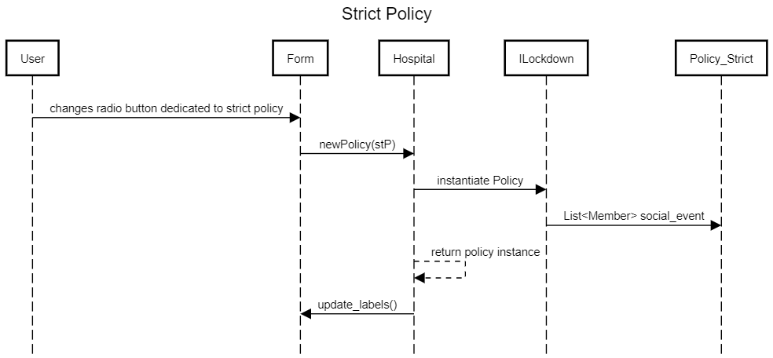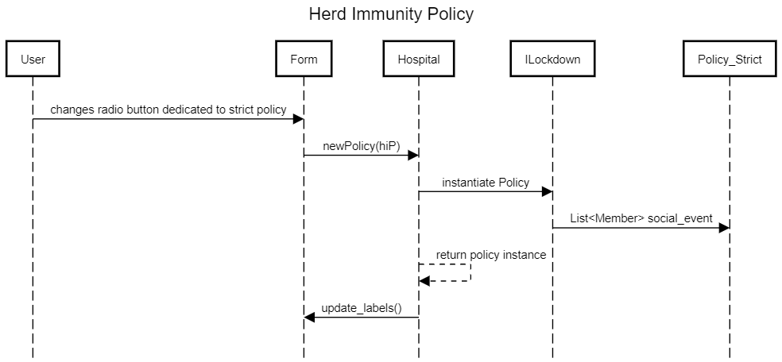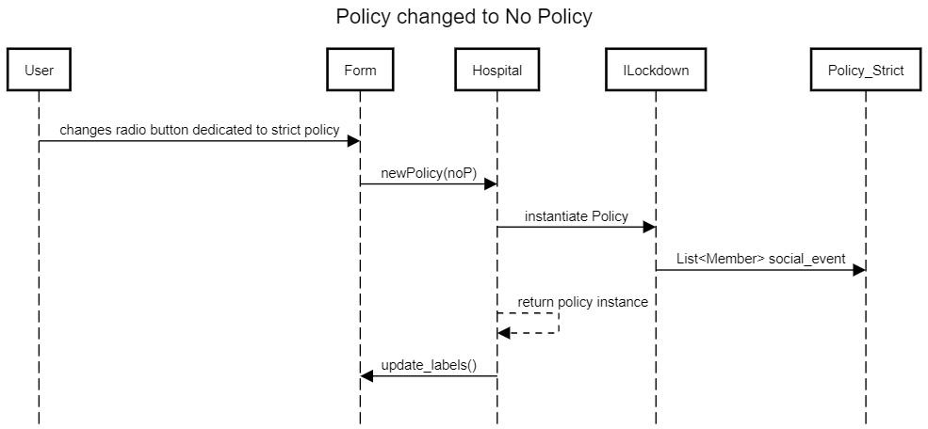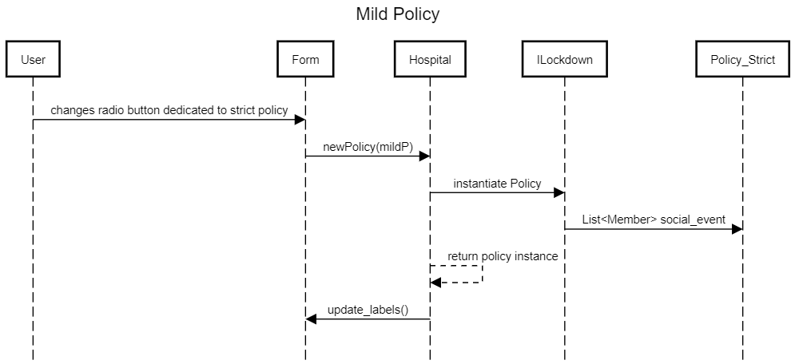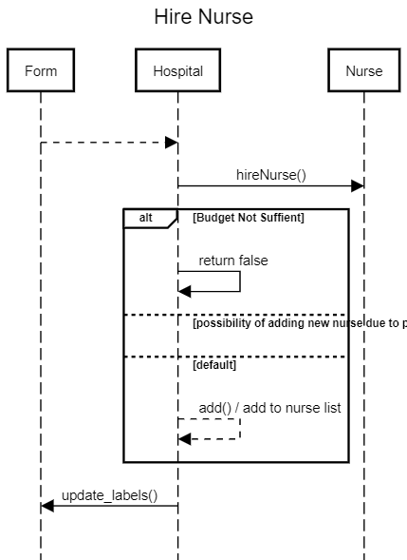

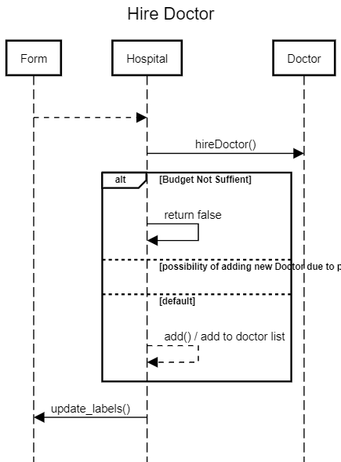

### Hospital - sequence diagram

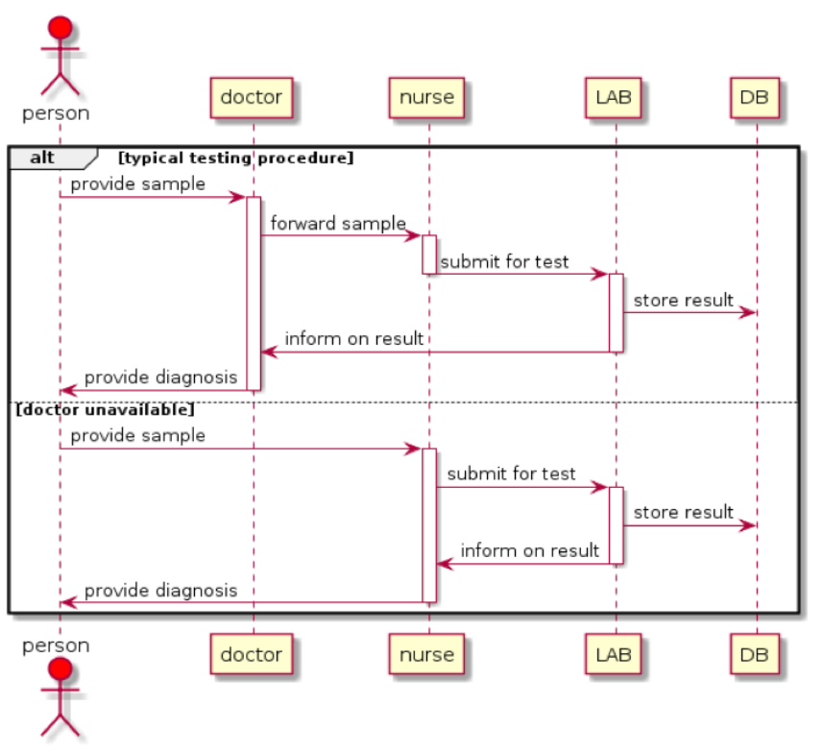

### 

### Unit tests - description

#### CalculateBlockCountTest

The method is dividing the population by area density and is comparing the result of this calculation to 1, it results in a less than one, and returns 1.

Arrange:

New Community with population “1”

Act:

Result is equal to community.calculateBlockCount()

Assert:

The result is equal to one, because the method returns 1

#### CalculateBlockCount2Test

The method is dividing the population by area density and is comparing the result of this calculation to 1, it results in equal or more than 1, and returns population divided by area density.

Arrange:

New Community with population “1000”

Act:

Result is equal to community.calculateBlockCount()

Assert:

The result is equal to community.getPopulation()/community.getAreaDensity()

#### GetNameTest

This method is returning a name of an object Person, name has to be equal to the actual name in the object.

Arrange:

New Person with parameters: name = “Name”, gender = 1, age = 20

Where gender = 1 means it is a female

Act:

Result is equal to person.getName()

Assert:

The result is equal to “Name”

#### GetAgeTest

This method is returning an age of an object Person, age has to be equal to the actual age in the object.

Arrange:

New Person with parameters: name = “Name”, gender = 1, age = 20

Where gender = 1 means it is a female

Act:

Result is equal to person.getAge()

Assert:

The result is equal to 20

#### GetGenderTest

This method is returning a gender of an object Person, gender has to be equal to the actual gender in the object.

Arrange:

New Person with parameters: name = “Name”, gender = 1, age = 20

Where gender = 1 means it is a female

Act:

Result is equal to person.getGender()

Assert:

The result is equal to 1

#### checkForMoreStaff_If_buget_more_then_0_ReturnsTrue

The method is checking if provided budget is more when 0

Arrange:

New Hospital with parameters population “5000”, budget “10000” and inticalPolicy “as Policy_none”

Act:

Result is equal to hospital.checkForMoreStaff()

Assert:

The result returns true, because budget above 0, it is 10000

#### getBudget_Returns10000

The method is checking if provided budget is equals to 10000

Arrange:

New Hospital with parameters population “5000”, budget “10000” and inticalPolicy “as Policy_none”

Act:

Result is equal to hospital.getBudget()

Assert:

The result is equal to 10000

#### getPopulation_Returns5000

The method is checking if provided population is equals to 5000

Arrange:

New Hospital with parameters population “5000”, budget “1000000” and inticalPolicy “as Policy_none”

Act:

Result is equal to hospital.getPopulation();

Assert:

The result is equal to 5000

#### getHerdSufficiency_60

The method is checking if herd sufficiency equals to 60

Arrange:

New Community with population “10000”

Act:

Result is equal to community.getHerdSufficiency()

Assert:

The result is equal to 60

#### getAreaDensity_500

The method is checking if area density equals to 500

Arrange:

New Community with population “10000”

Act:

Result is equal to community.getAreaDensity();

Assert:

The result is equal to 500

#### getPopulation_10000

The method is checking if population is equals 10000

Arrange:

New Community with population “10000”

Act:

Result is equal to community.getPopulation();

Assert:

The result is equal to 10000

#### getCultureType_declared_value_Median

The method is checking if culture type is Median

Arrange:

New Community with population “10000”

Act:

Result is equal to community.getCultureType();

Assert:

The result is equal to Median